**Alternate medicine Test Cases :**

1) prozosil 40 tablet

1. levocetri 5mg tablet
2. znp 100mg/500mg tablet
3. ketorocin eye drop
4. moxifinity 400mg tablet
5. zykuf oral drops

**Output:**

1)

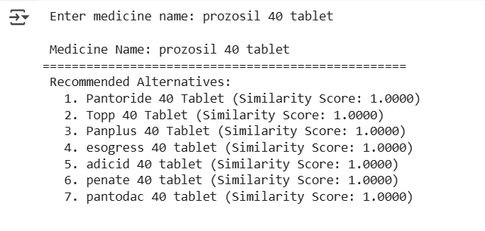

2)

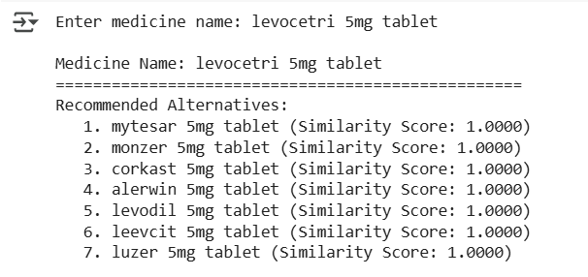3)

